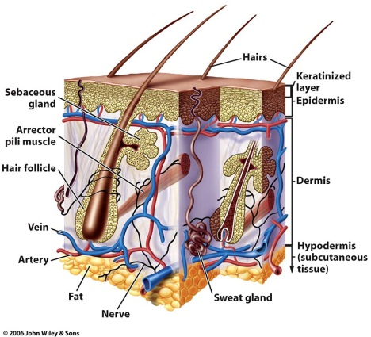**Hair Analysis**

1. **Overview**

* Hair can be very valuable to forensic scientists.
* Need to be familiar with hair ______________ and ______________.
* A hair is composed of three layers:

_________________, _________________, and _________________.

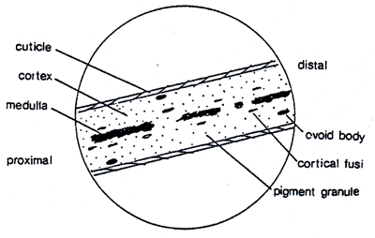

1. **Structure**
2. _________________

1. Hard, ________________ covering that ________________ the inner layers.

2. Made of ________________ layers of ________________.

3. Differ in types and arrangements of scales.

Types of ________________

* ________________ scales: found on very fine hair of ________________ and ________________, rarely in ________________
* ________________ or petal-like scales: ________________ off from shafts of hair. NOT found on ________________, found on ________________, ________________, ________________, etc.
* Imbricate or ________________ scales: overlap (like ________________). Found on ________________ and some animals

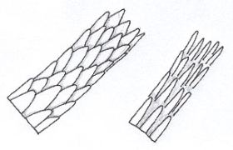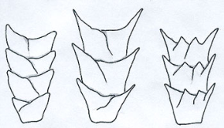

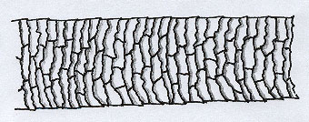

1. _________________
2. Made of ________________ within the cuticle.
3. Makes up ________________of ________________ hair.
4. Contain ________________ that give hair its ________________.
5. Forensic scientists use ________________, shape, and ________________ of ________________ granules.
6. _________________
7. Made of ________________ that run through the ________________ of the ____________.
8. May be ________________, ________________, ________________, or _______________.

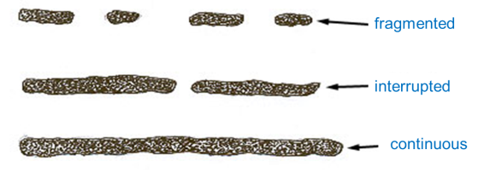

1. Forensic scientists use the medullary _____________, medullar ______________ and shape.

Medullary Index

=diameter of medulla / diameter of hair

* + - * Humans🡪 index is ________
      * Animals🡪 index is _________
      * Thus ________________ generally have a ________________ medulla than ________________

1. ________________

* Human roots ________________ different based on whether they have been ________________ ________________ or if they are telogen hairs and have ________________.
* ________________ roots will vary, but in general have a ________________ shape.

1. **Hair Identification Factors**
   * Because humans ________________ their hair with color or other ________________, this ________________ in identification
   * ________________ can be in the ________________ and ________________
   * Bleaching removes the color and gives it a ________________ tint.
   * ________________ of colored “________” helps with id.
     + - Hair ________________ ~____ cm/month
2. **Process of Analysis**

* ______ determine whether hair is ________________ or ________________.
* If ________________: they compare hair to that of ________________ using ________________ scopes.
* Then determine ________________: ________________, ________________, ________________, etc.
* Hair can be used to determine ________________.
* If ________________: they ________________ the animal.

1. **Other Important Points . . .**

* Hair is one of most ________________ types of ________________ evidence
* Hair ________________ be used to ________________ suspects or scenarios and to ________________ (________________) other evidence
* Hair NOT ________________ type evidence unless the ________________ is present (can obtain ______________ sample from ________________ cells in hair ________________)
  + DNA from hair
    - The ________________ contains ________________ DNA. If the hair has been ________________ removed, some ________________ tissue may be attached containing ________________.
    - The hair ________________ contains abundant ________________ DNA, inherited only from the ________________. It can be typed by comparing ________________ if no DNA from the body is available.